

**Summary**

Contents

**.**

Business OutSourcing Industry 2

Goals of the project 2

Practice & Implementation 2

GitHub & Work Rates 3

Conclusion 6

**Business Outsourcing Industry**

Team Kernel Express: <https://team-kernel-express.myshopify.com/>

The main goal or destination of the outsourcing industry is to facilitate global (international) trade between worldwide consumers and China, outsourcing is a great way to reach out to other countries and advertise Chinese products so the world can see what China has to offer. Planning an outsourcing engagement requires careful consideration of both strategic and tactical issues. Tactical issues include work descriptions, processes, service level requirements and so forth. The main strategic consideration is how outsourcing is aligned with overall business goals. I suggest companies start by creating an overarching strategy to guide tactical planning, implementation and life-cycle success.

* **Business Efficiency** – This approach is used where the goal is to maintain existing processes and service performance, while cutting costs.
* **Business Enhancement** – This approach builds on the efficiency option but adds the goal of improving services through process improvements, reengineering, new technologies, etc.
* **Business Transformation** – This approach extends well beyond the efficiency and enhancement options. Here the focus is making step-change improvements in business performance through fundamental changes in the way the business operates.

**Goals of the Project**

Our Mission

To facilitate global trade between worldwide buyers and Chinese suppliers.

To provide accurate and dependable information on Chinese products and suppliers to global buyers.

To help buyers and suppliers communicate and do business with each other effectively and efficiently

**Practice and Implementation**

Our practice and implementation for this project went on well and in an organized manner, here is a breakdown of how we started everything.

**Planning**

The team leader made a group on wechat that we used for communication and clarification. All group members fully participated and were well informed in the group with questions asked where not clear.

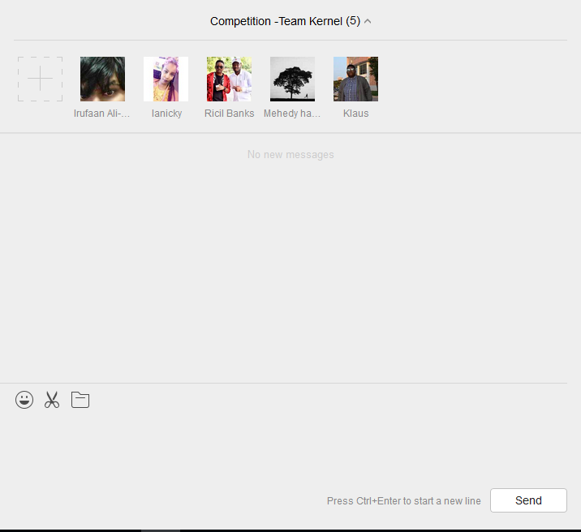

**GitHub**

The group leader made a GitHub repository and invited all members of the group to that repository (team Kernel competition) for the innovative application competition for the service outsourcing website set for completion in March 2018.

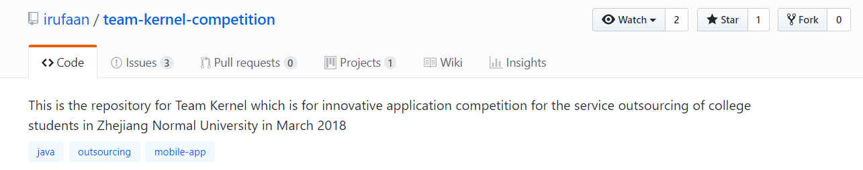

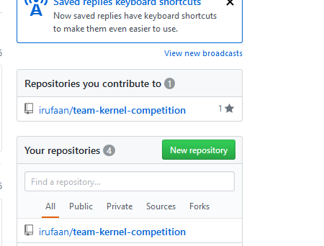

**Introduction**

Then we had a brief intro on what our way forward was to be such as requirements and so on…

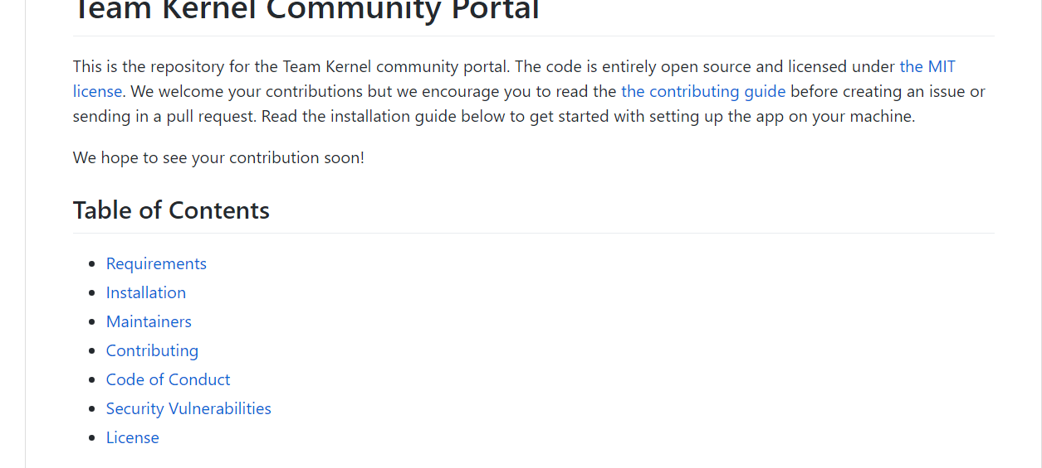

Then folders were made for each individual in the group where we were to send all required documentation and queries regarding tasks that were handed to each particular individual like this:

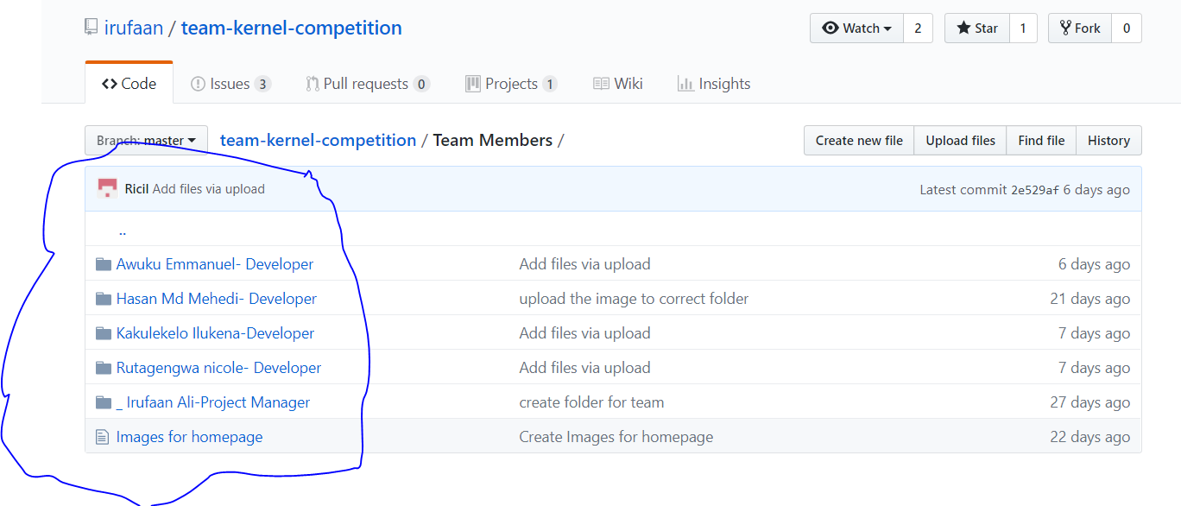

Specific tasks were assigned to each team member based on their special area of skills over the course of this project with a deadline given and requirements to be met

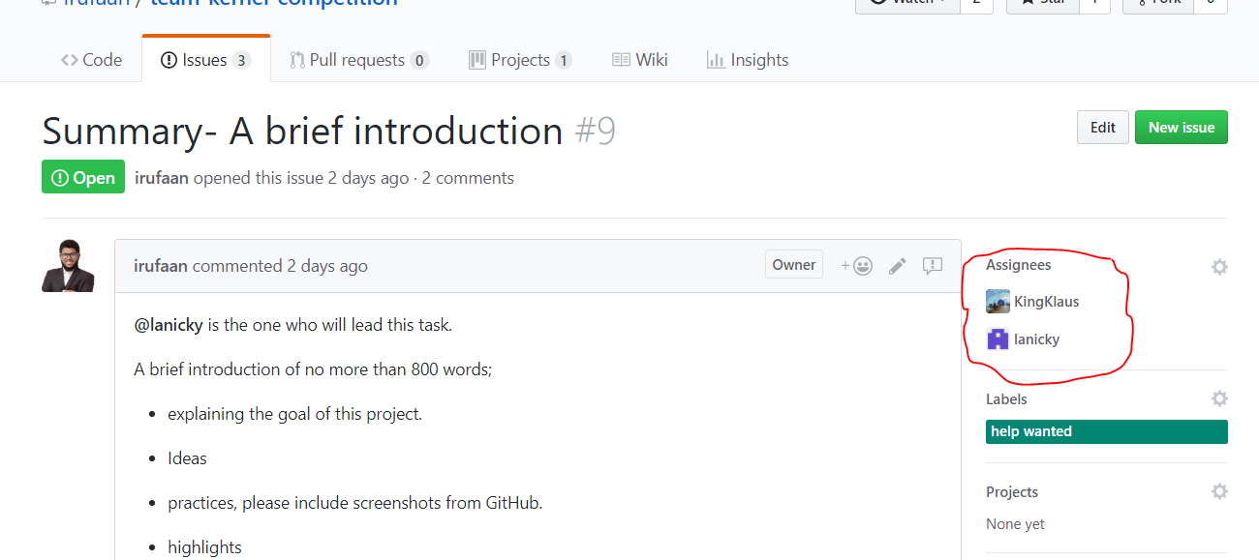

For example in the task in the screenshot titled “Summary – A brief Introduction” one can clearly see the assignees in the circled red marker….these people were responsible to handle the given task and complete in/on time.

**Work Rate**

The beauty of GitHub is that one cannot simply cheat, it has a work rate meter that gauges how much every team member contributes and how much work they put into that particular repository

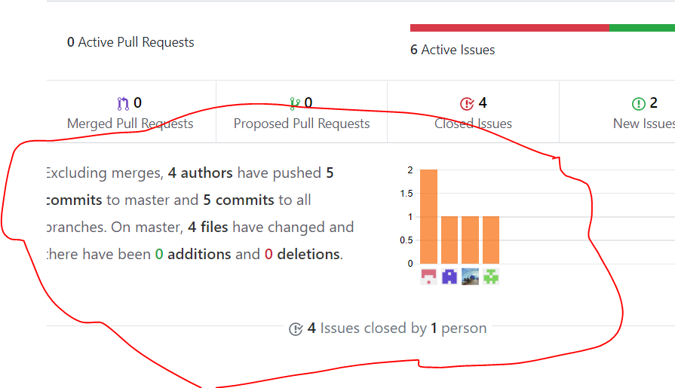

The graph illustrates the work ethic put in by team members which I must express as good aswell as the representation of the commits

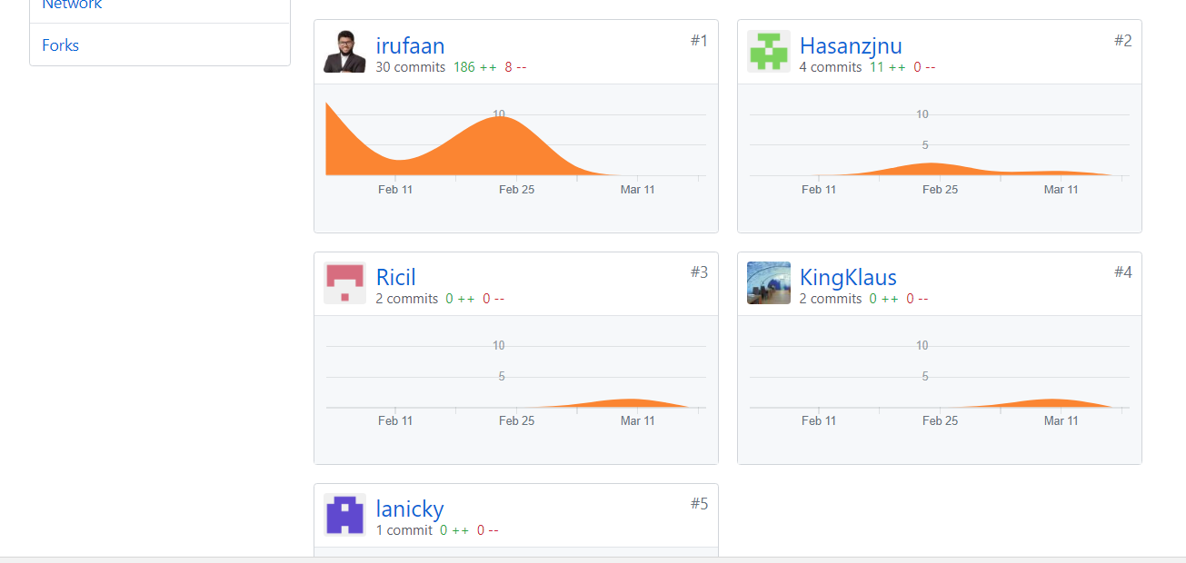

**Conclusion**

GitHub is the future of programming and the handling of big projects, it is fast, reliable and robust. The whole competition and its progression has been an eye opening experience into outsourcing and how it affects our day to day lives, outsourcing is definitely one for the curb and I feel is a great way to even increase a country’s revenue as well as economy as it has an impact on the economy.